# INTRODUCTION

* 1. Overview

Startups, in India as in many other parts of the world, have received increased attention in recent years. Their numbers are on the rise and they are now being widely recognized as important engines for growth and jobs generation. Through innovation and scalable technology, startups can generate impactful solutions, and thereby act as vehicles for socio-economic development and transformation.

* 1. Purpose

The aim of this study is to provide a comprehensive understanding of both the growth drivers as well as the challenges faced by Indian startups. Further, the study investigates how the startup ecosystem has developed over the years and describes where and which kind of support is available. While the primary focus is on technology-driven startups, the study recognizes that non-tech, social and micro-entrepreneurs have also come up with innovative ideas and solutions.

1. **Problem Definition & Design Thinking**
   1. Empathy Map

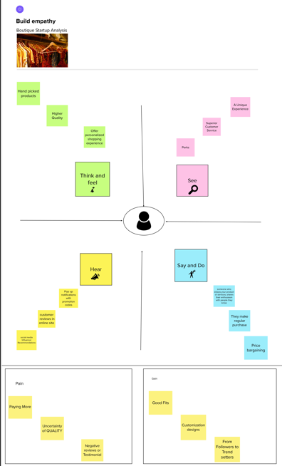

* 1. Ideation & Brainstorming Map

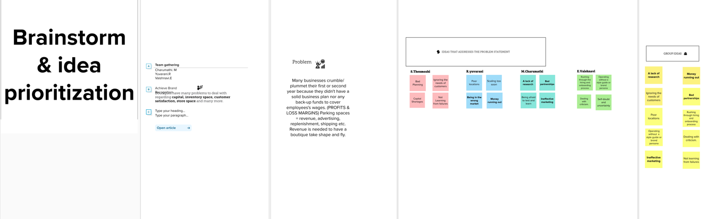

# RESULT

# DASHBOARD:1

# 

# DASHBOARD:2

# 

# DASHBOARD:3

# 

# STORY:

# 

# WEB INTEGRATION:

# 

# 

# ADVANTAGES & DISADVANTAGES

# Advantages:

# 1. Agility

# Startups are smaller and less structured. They are also innovative and keep improving their business models, processes, and portfolio. These allow them to adapt to disruptive technologies and changes in market conditions. Established competitors face vested interests, a historic path, and a strong team culture. This makes them resistant to change.

# 2. Efficiency (Lean and Mean)

# Established companies have high administrative overheads. Startups offer their services in a more efficient, cost-effective and competitive manner. They are likely to be aware of their limitations and tend to focus on their core strengths. This causes them to partner with other small organizations. Customers often benefit with a superior value proposition.

# 3. Team Culture

# Employees of large corporations get attracted by prestige and big salaries. They easily lose sight of the company’s vision, mission and values and the success of its customers. Startup employees form a close-knit community that shares passion, beliefs, and values. They must work together for the good of the company, its customers and the world at large.

# 4. Personalization

# Startups deliver their products and services with a personal touch. This creates a uniquely personal experience for their customers. Startups also take time to study and understand their customers’ business requirements. This allows them to build lasting relationships with specific offerings and responsive solutions.

# 5. Versatility

# Startup employees multitask and the salesperson could double up as the relationship manager. This adds continuity to customer relationships and enables startups to respond to emergencies. Most startups support learning and have a higher tolerance for mistakes. Both factors enhance the versatility of startup employees.

# 6. Fun

# Last but now least, working with a startup could be a lot more fun. A startup doesn’t have to please everyone and may decide to select clients that are fun to work with. Spontaneous fun activities after work are a lot easier to organize in a startup. Your colleagues could become your best friends.

# Disadvantages

# 1. Risk

# Most startups fail within their first year of operations, so the risk of failure is high. Working under such high risk can blur a startup’s strategic vision. So they either fail to seize market opportunities or overestimate their sales projections. High risk also hinders a startup’s ability to attract experienced and competent staff.

# 2. Compensation

# It takes blood, sweat, and tears to build a company, and long working hours are the norm for startups. The rewards might be low since it takes time to generate revenue and make profits. Some startups give up since it’s demotivating to work without proper compensation.

# 3. Market Access

# Many customers prefer a business that they have worked with over a new startup. Besides it is more expensive to acquire new customers than to retain old ones. Without a customer base, understanding market needs also becomes a real struggle. All these factors combined increase the cost of business development for startups.

# 4. Team Composition

# Some startups are born out of desperation since the founder could not find or hold on to a job. Such founders often struggle to build a team that the business needs to succeed. A successful startup requires founders/co-directors with complementary personalities and competencies. Even then disagreements can creep in when the going gets tough.

# 5. Resources

# Growth hacking, cloud computing, and venture capitalism allow startups to gain market entry. Most startups operate on a shoestring budget, against competitors that are well-resourced. It gives the competitors an edge in product development, sales, and marketing. They use that edge to push startups out of the market when they become a threat.

# 6. Processes

# Startups are flat organizations that lack defined business processes and operational procedures. This exposes them to poor customer service, legal liability, and financial losses. Startups might thus opt to outsource non-core business processes to external service providers. But the high associated costs could form a barrier.

# 7. Stress

# We did mention that working for a startup is fun, but it could also become very stressful. Low compensation, many responsibilities and long working hours are more or less expected. Add legal prosecution, imminent business failure, and screaming customers and work becomes unbearable.

# APPLICATIONS

# There are many benefits to using data analytics for startups, and here are just a few:

# Data analytics can help you identify patterns and trends in your data that you wouldn't be able to see otherwise. This can help you improve your product or service in ways that you never thought possible.

# Data analytics can also help you identify which areas of your business are most profitable and which ones need more attention. This can help you prioritize your resources accordingly, making sure that you're investing in the areas that are most likely to succeed.

# Data analytics can also help you track user behavior and determine what kind of feedback they give you. This helps you create better products and services that meet their needs and expectations.

# Finally, data analytics can help you measure the success of your company both short-term (in terms of revenue) and long-term (in terms of customer retention).

# CONCLUSION

# Data analysis can help small businesses change how they promote their products, engage with clients, and manage finances. It can not only provide actionable insights into user behavior but assist with reducing costs, driving revenue, and providing a one-of-a-kind customer experience that makes people stay.

# FUTURE SCOPE

According to an IBM report, Data Science jobs would likely grow by 30 percent. The estimated figure of a job listing is 2,720,000 for Data Science in 2023.

Every organization wants to gain supreme profits. As data is the key factor in Data Science, every industry has realized that it requires Data Scientists to play with data to optimize its business profits. This is the reason for the popularity of Data Science jobs.

Also, in this digital world, there are diverse classes of businesses. Organizations managing these diverse classes deal with zettabytes (a billion Terabytes) of data. In the upcoming years, this data will continue increasing in huge proportions day by day, and it would, in turn, increase the demand for skilled individuals in Data Science in 2023.

# APPENDIX

# A. Source Code

file:///C:/Users/new/Downloads/startup%20analysis/dashboard.html

file:///C:/Users/new/Downloads/startup%20analysis/index.html